Wanted: Dead

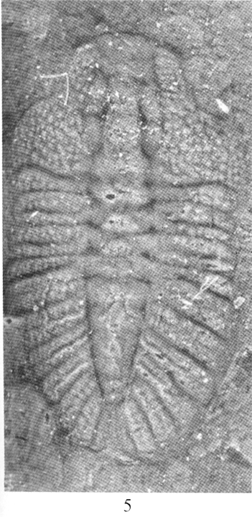

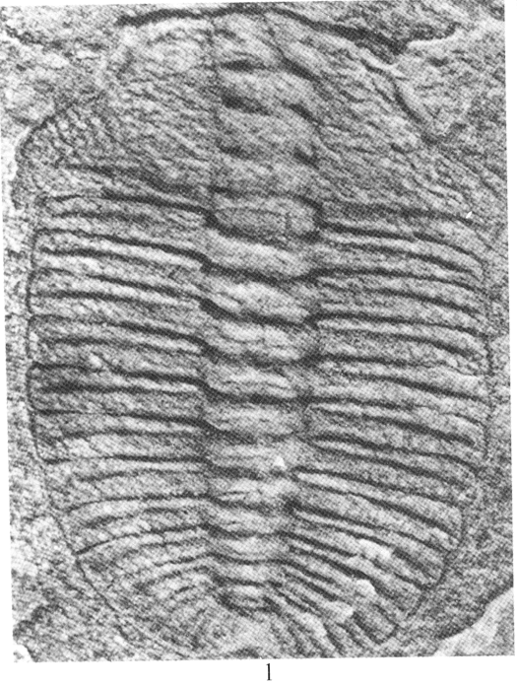
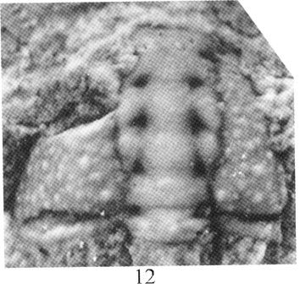
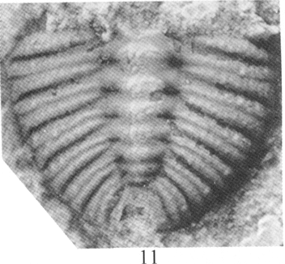

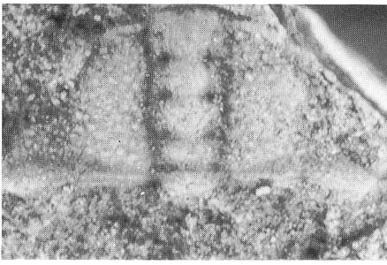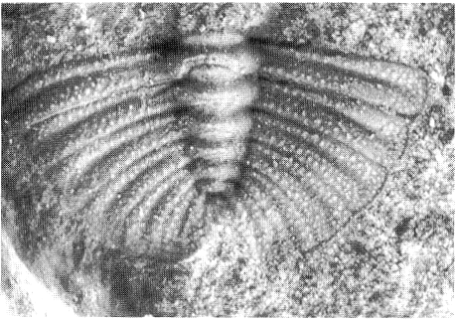

Ovatoryctocara granulata
from the lowermost Middle Cambrian—last seen in Greenland, Newfoundland, Russia, and China.

Possible sighting in Nevada!

Arthricocephalus chauveaui
from the Lower Cambrian (lower to middle Olenellus Biozone)—last seen in Greenland and China

If found, please contact Sheriff Fred Sundberg at freddeb85@cableone.net

Wanted for their usefulness is correlating Cambrian rocks across the world. These trilobites have not been found in the Western United States and their discovery would greatly help in establishing international correlations. (In case you did not know—the Lower-Middle Cambrian boundary is not at the same level in different countries and is very difficult to correlate).

